Best of Dayton Finalist voting is now open!
It’s the home stretch to the finish line – FINALIST VOTING is happening – and you need all the support you can get!
An easy way to get votes is to reach out to your customers, fans, friends and family to VOTE for you in our 2022 Best of Dayton contest, on Dayton.com and DaytonDailyNews.com.
Below are sample social media messages you can post, or send in an email, for your bid to be the Best of Dayton.
Post the messages below with your own photos or use the graphics we made for you! If you use your own photos – you can put our Best of Dayton logo on them to get attention!
URL to post: https://bit.ly/BestofDayton2022
FINALIST VOTING period – Sept. 6 – Sept. 26
Facebook posts
#1 Post
We made it! We’re a finalist in the 2022 Best of Dayton contest on Dayton.com.
Now we need you to VOTE for us to WIN the Best of Dayton (enter category you are in here)!
You can vote for us daily until Sept. 26 at https://bit.ly/BestofDayton2022
#2 Post
Can you help us be named a BEST OF DAYTON!? We’re a finalist for (enter category you are in) and need you to VOTE for us to win at https://bit.ly/BestofDayton2022
You can vote for us daily until Sept. 26!
#3 Post
Do you think we’re the Best of Dayton? Well, then help us make it official – VOTE for us today to be named a Dayton.com Best of Dayton 2022 (enter category you are in here – example: Best Coffee House)!
Vote for us daily through Sept. 26 at https://bit.ly/BestofDayton2022
Instagram
Instagram stories
Adding photos and links to your Instagram stories is the best way to reach your audience. Do you know how to add a link to your Instagram stories? When you’re making a story, hit the smiley face in the upper right corner, and then hit the LINK option.
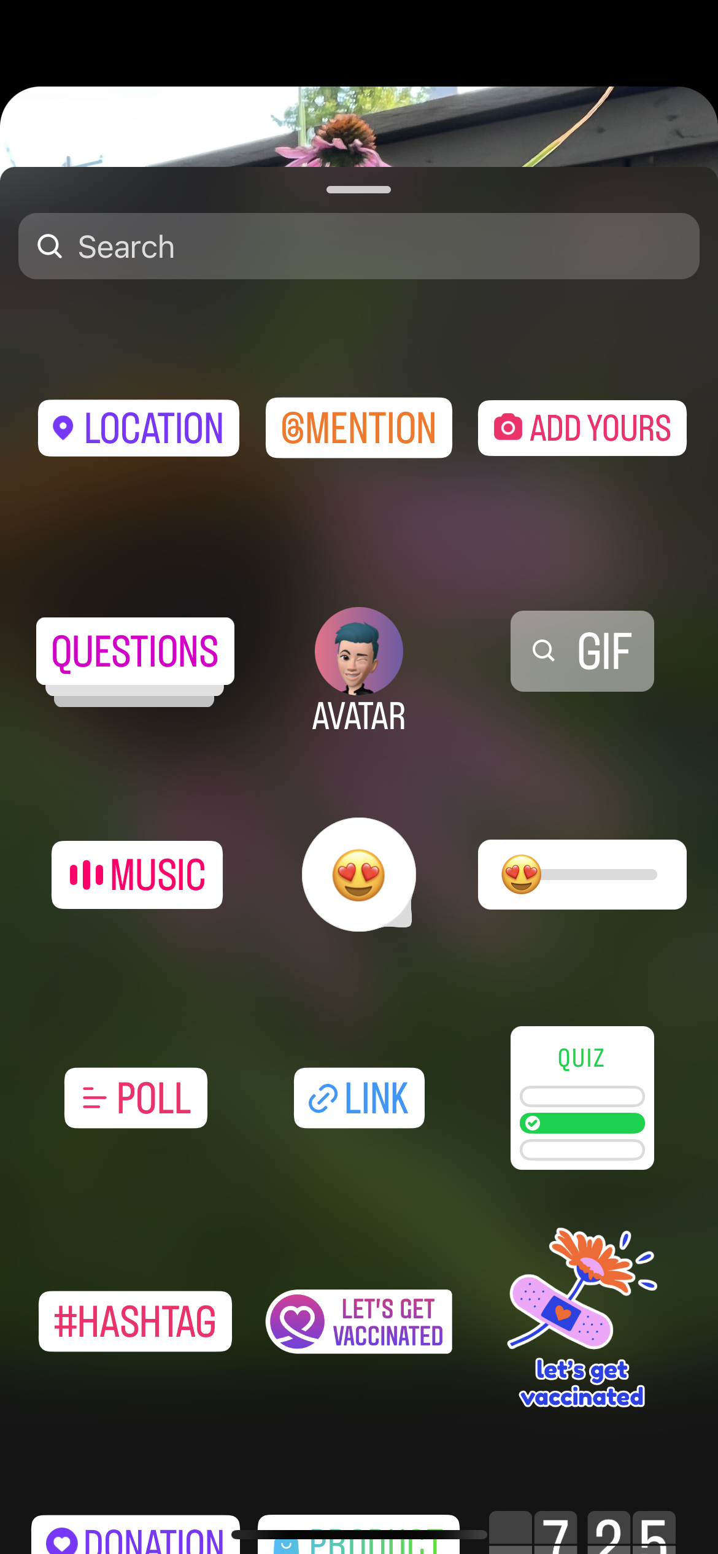
Paste in this URL to the link generator, and it will add the nominate URL to your story, that your fans can click directly to. URL to use: https://bit.ly/BestofDayton2022
Add our “Vote for us” graphic we provided to your story, with the message “Vote for us today for (enter category you are in here – example: Best Coffee House)! And then include the LINK option to your story
Timeline posts
#1 Post
HELP US to be named a @daytondotcom Best of Dayton 2022! Vote for us today for (enter category you are in here – example: Best Coffee House) on Dayton.com. #BestofDayton
#2 Post
Do you think we’re the Best of Dayton? Well, then help us make it official – Vote for us as the Dayton.com Best of Dayton 2022 (enter category you are in here – example: Best Coffee House)! Voting happening now through Sept. 26 on Dayton.com #BestofDayton
Twitter
#1 post
HELP US to be named a @daytondotcom Best of Dayton 2022! Vote for us today for (enter category you are in here – example: Best Coffee House) at https://bit.ly/BestofDayton2022 #BestofDayton
#2 post
Do you think we’re the Best of Dayton? Well, then help us make it official – Vote for us as the Dayton.com Best of Dayton 2022 (enter category you are in here – example: Best Coffee House)! Voting happening now through Sept. 26 at https://bit.ly/BestofDayton2022
Email blast
We made it to the finals of the Dayton.com Best of Dayton 2022 contest – and YOU can help us win!
All you have to do is go to https://bit.ly/BestofDayton2022 and vote for us in the enter category you are in here – example: Best Coffee House) category! You can vote daily now through Sept. 26!
Thanks for helping us on our quest to be an official Best of Dayton!

