Best of Dayton returns!
A great way to get exposure for your brand is to be a Best of Dayton finalist or winner! How do you do that? Ask your customers, fans, friends and family to NOMINATE and VOTE for you in our 2022 Best of Dayton contest, on Dayton.com and DaytonDailyNews.com.
Below are sample social media messages you can post, or send in an email, for your bid to be the Best of Dayton. Post the messages with your own photos or use the graphics we made for you! If you use your own photos – you can put our Best of Dayton logo on them to get attention!
URL to post: https://bit.ly/BestofDayton2022
NOMINATION period – Aug. 8 – Aug. 22
Facebook posts
#1 Post
Nominate us to be in the running to be the Best of Dayton (enter category you want to be named in here)!
The more you nominate us, the better. You can nominate us daily through Aug. 22 at https://bit.ly/BestofDayton2022
#2 Post
Hey! We have a favor to ask ... can you help us be named a BEST OF DAYTON!? Nominate us today for (enter category you want to be named in here) at https://bit.ly/BestofDayton2022
You can nominate us daily now through Aug. 22!
#3 Post
Do you think we’re the Best of Dayton? Well, then help us make it official – nominate us today to be named a Dayton.com Best of Dayton 2022 (enter category you want to be named in here – example: Best Coffee House)!
Nominate us daily through Aug. 22 at: https://bit.ly/BestofDayton2022
Instagram
Instagram stories
Adding photos and links to your Instagram stories is the best way to reach your audience. Do you know how to add a link to your Instagram stories? When you’re making a story, hit the smiley face in the upper right corner, and then hit the LINK option.
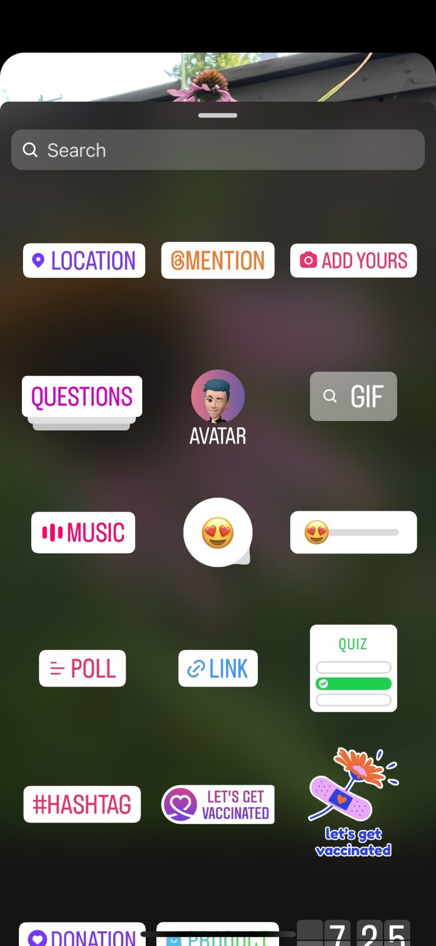
Paste in this URL to the link generator, and it will add the nominate URL to your story, that your fans can click directly to. URL to use: https://bit.ly/BestofDayton2022
Add our “Nominate us” graphic we provided to your story, with the message “Nominate us for (enter category you want to be named in here – example: Best Coffee House)! And then include the LINK option to your story
Timeline posts
#1 Post
HELP US to be named a @daytondotcom Best of Dayton 2022! Nominate us today for (enter category you want to be named in here – example: Best Coffee House) on Dayton.com. #BestofDayton
#2 Post
Do you think we’re the Best of Dayton? Well, then help us make it official – nominate us today to be named a Dayton.com Best of Dayton 2022 (enter category you want to be named in here – example: Best Coffee House)! Nominations are open NOW on Dayton.com
Twitter
#1 post
HELP US to be named a @daytondotcom Best of Dayton 2022! Nominate us today for (enter category you want to be named in here – example: Best Coffee House) at https://bit.ly/BestofDayton2022 #BestofDayton
#2 post
Do you think we’re the Best of Dayton? Well, then help us make it official – nominate us today to be named a @Daytondotcom Best of Dayton 2022 (enter category you want to be named in here – example: Best Coffee House)! Nominations are open NOW at https://bit.ly/BestofDayton2022
Email blast
Hello friends! We need your help – we're on a mission to be the Best of Dayton, so we need you to nominate us for a Dayton.com Best of Dayton 2022 (enter category you want to be named in here – example: Best Coffee House)!
It’s easy – go to https://bit.ly/BestofDayton2022 and nominate us. You can nominate us daily now through Aug. 22!
Thanks for helping us on our quest to be the Best of Dayton!
P.S. - If we get enough nominations, we’ll be named a Finalist in the competition, which the finals voting will start in September. Stay tuned, and we’ll let you know if we make it to the finals!

